Connect to Development Server & MySQL Remotely

## How Ubuntu 16.04 was configured

**Please note: This is already configured on the dev server. Do not do this again!**

Edit the mysqld.cnf file, type in the following command



Comment out 127.0.0.1, and add the address 0.0.0.0, and save the file.



I installed openssh using the following command: *sudo apt install -y openssh-server*

Check if ssh is running: sudo systemctl status ssh

I added our devadmin admin user as a sudo user, using the following usermod command



Edit the ssh config file: nano edit /etc/ssh/sashd_config

Make sure Port 22 is not commented.

Then change the following settings:

* PermitRootLogin no
* AllowUsers devadmin

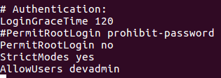

Save file, then restart ssh server: service ssh reload



Then restart ssh service: service ssh restart



Check if ssh is running: 

You should get the following status: active (running)

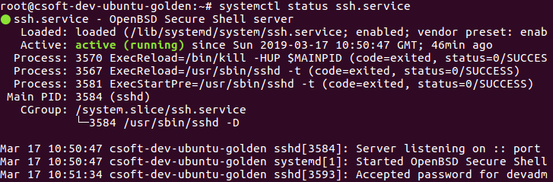

I added a dbadmin user. To log into mysql on Ubuntu, use the following command: mysql -u root -p



Type the following commands (press enter after each line):

***CREATE USER 'dbadmin'@'localhost';***

***GRANT ALL PRIVILEGES ON *.* TO 'dbadmin'@'localhost' IDENTIFIED BY 'refer to password in Slack';***

To check if your user is added, type: ***select user, host from mysql.user;***

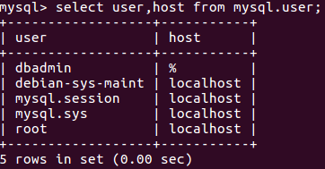

Now you need to restart the mysql service: service mysql reload (this reloads the config file)



Then restart mysql service using the following command:



Check the mysql status: service mysql status

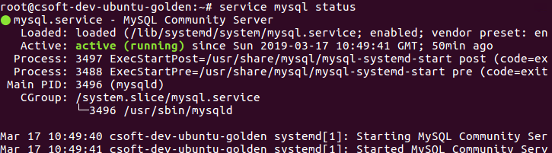

## Test connection using Putty

* Open Putty
* IP Address: 172.28.25.133
* Port: 22

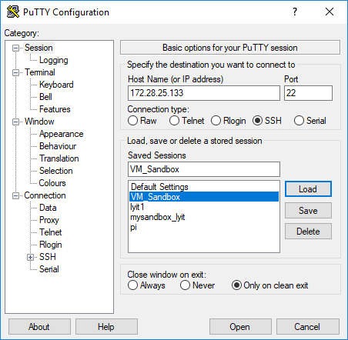

Type in username: devadmin

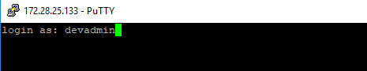

Type in password: Password available on Slack only

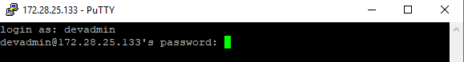

You’re in!

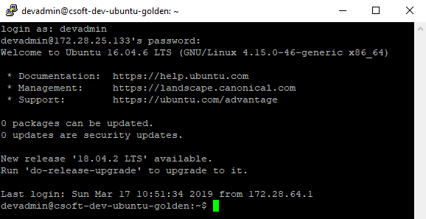

## Log into MySQL Database Remotely

You will need MySQL Workbench if you would like to access the MySQL database from you desktop / home pc. Here is the link (It’s open source): <https://dev.mysql.com/downloads/workbench/>

Open MySQL Workbench, and go to Database, Connect to Database

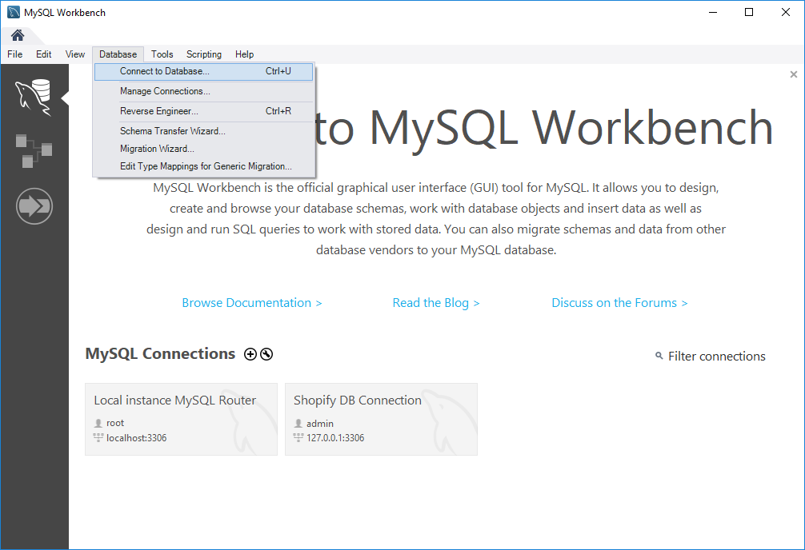

Click on Connection Method and select: Standard TCP/IP over SSH

Change the following settings

* SSH Hostname: 172.28.25.133:22
* SSH Username: devadmin
* SSH Password: refer to dev server password posted on Slack (You can store the password in Vault)
* MySQL Hostname: 172.28.25.133
* MySQL Server port: 3306
* Username: dbadmin
* Password: refer to dev server password posted on Slack (You can store the password in Vault)

Then click on OK

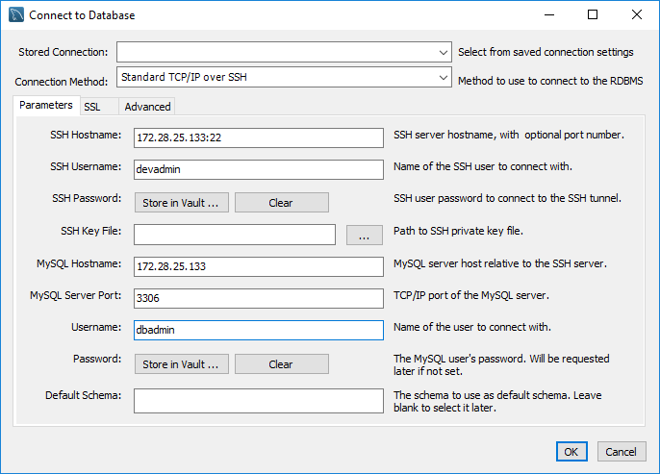

If you see the following screen, you’re in! If not, check your settings.

